**Project Proposal**

**Data Aggregation and Analysis with Python in the field of Renewal Energy Systems**

**Hypothesis**

**Introduction**

Since the dawn of time, energy has been at the heart of economic progress and industrialization. The growth of national economies and energy consumption are thought to have a linear and positive relationship. Renewable energy generation has gained traction in the global energy sector in recent years, and it is rapidly being hailed as the "fuel of the future." The interrelationships between the renewable energy sector and economic growth, on the other hand, are not well understood. The effects of renewable energy production in emerging and industrialised economies have not been thoroughly studied.

The world's energy system is predominantly dependent on fossil fuels, which account for approximately 80% of total energy supply in the global economy. However, some serious issues relating to the utilisation of fossil fuel energy have surfaced in recent years. The growing imbalance between energy demand and supply in the global economy, the increasing threat of oil resource exhaustion, and the high level of greenhouse gas emissions in the environment are among these concerns. Carbon released during the development of fossil fuels is now recognised as the "primary source of humanity's environmental crisis."

In light of the numerous crises in the energy sector, there has been a growing emphasis in recent years on the development of "clean" renewable energy sources. As environmental degradation continues apace, many industrialised and developing countries are pursuing a "green" growth goal, allowing economic expansion and environmental conservatism to coexist.

The mainstreaming of renewable energy technologies and the creation of a viable green energy market are two primary goals of this "green" growth plan. Renewable energy technologies are being hailed as the "next green revolution," promising to help reconcile the competing demands of strong economic growth and a sustainable development path.

Our Research will be done through Data Science, Data science is a branch of data analytics and data visualisation in which unstructured or raw data is cleaned and prepared for analysis. This data is used by data scientists to obtain the necessary information for future purposes. Data analytics is primarily concerned with putting historical data into perspective, whereas data science is more concerned with machine learning and predictive modelling. Data science and analytics makes multidisciplinary approach to solving analytically complicated business problems that includes algorithm creation, data inference, and predictive modelling.

As each segment of the market expands and data accumulates on a daily basis, we must maintain track of data that can be used for analytics and evaluation. We now have zetta and peta level of data instead of GBs and terabytes, which cannot be processed by previous conventional methods.

**Overview and Background**

Over the last 500 years or so, people have become increasingly reliant on dirtier, cheaper energy sources like coal and gas. A dramatic transformation in the sectors of energy production and consumption is becoming more necessary as a result of climate change induced by anthropogenic CO2 emissions originating from the use of fossil fuels. Integration of renewable energy sources (RES) into current energy systems, as well as a stronger coupling of energy forms and sectors, are key parts of addressing this challenge.

The development of the energy sector has been followed by a persistent effort to model and predict it. The first attempts to anticipate future energy demands date back to the 1950s and are based on simple assumptions.

Since the 1970s and 1980s, when the first Energy Saving Models (ESMs) were developed, which were based on optimizations rather than simulations, their creators have faced two major decisions: whether to focus on economic mechanisms, which is sometimes referred to as a top-down approach, or on the technical dimension, which is usually referred to as a bottom-up approach.

As a result, the recent flurry of articles on ESM aggregation approaches demonstrates that many application scenarios are far too complex to be solved purely through CPU power and theoretically comparable transformations.

Due to the growing implications of climate change, energy customers and communities are asking that their electricity be sourced from greener options. In response, governments have devised legislative systems, such as Renewable Portfolio Standards (RPS) and carbon trading markets, that incentivise electric utility companies to add Renewable Energy Resource (RER) to their generation portfolios.

Renewable energy is frequently thought of as a relatively new technology. Renewables are becoming a more essential power source now that we have more innovative and less expensive ways to catch and keep wind and solar energy. Renewable energy is expanding at all scales, from rooftop solar panels on residences that can sell power back to the grid to massive offshore wind farms. For heating and lighting, several rural communities rely entirely on renewable energy.

**Problem Statement**

We do have a concept for renewable energy systems to address all of the above-mentioned difficulties. Electric utilities, energy balancing authorities, market dispatchers, and the ageing electric infrastructure at large have faced economic, operational, and systematic issues as a result of the expansion of Renewable Energy Systems, particularly PV solar and wind power.

Renewable Energy Systems, for all of their benefits to the electric utility business, have unforeseen and negative repercussions on the electric grid. RES supply energy to meet daily energy demand, but they are not well-suited to delivering grid services, which are essential for power system resilience.

They are also weather-dependent, and they frequently result in unscheduled ramping events due to fast fluctuations in power output.

Our project's main purpose is to update the power grid, making it smarter, more secure, and better integrated across areas as renewable energy usage grows.

As the number of renewable energy systems grows, so does the amount of renewable energy data collect by sensors and other energy system components. So, once again, big data might be useful in gaining a better understanding of the current state of the renewable energy business and also additional feature like forecasting, predictions and many more will be added with the help of data aggregation artificial intelligence (AI Machine Learning).

**Project aims and objectives**

The major goal of renewable energy deployment is to promote economic development, improve energy security, increase energy access, and mitigate climate change. Sustainable development can be achieved through the use of renewable energy and assuring citizens' access to inexpensive, reliable, sustainable, and contemporary energy. We hope to show key accomplishments, prospects, projections, electricity output, as well as issues that arise in renewable energy systems owing to a variety of factors.

We will be able to acquire large amounts of data with the help of data science, which will be processed and analysed using a variety of approaches. Data in a structured or unstructured format will be filtered, and a number of needed tasks for analysis will be completed using a high-level programming language. This information is then processed and presented to help us better understand and evaluate it.

The applications of data science that play a vital part in our renewable energy initiative are listed below.

* Enhancing present technology This is primarily utilised in the solar energy field. Solar panel data is acquired via sensors, and by analysing the data pattern, we may increase the efficiency and life term of the solar panel in question.
* Predictions for renewable energy use, the consumption of renewable energy by customers can also be anticipated using historical data on customer energy consumption. This could be quite beneficial in the future when it comes to meeting customer needs.
* Forecasting renewable energy generation, the production of solar and wind energy can be optimised by taking into account weather and environmental data. Forecasting will be simple with this information.
* Lowering the Costs of Renewable Energy Production, with the large amount of energy data at our disposal, we can simply forecast the cost of renewable energy production using a forecasting model. Because of the huge data and forecasting models available to us, the price of energy is falling. Renewable energy will be competitive with its traditional counterparts in terms of cost.
* Power plants with a reliable backup system, we can easily get the high and low power usage with the assistance of computational models, and when there is ample power, we can conserve the power that would otherwise be wasted, and when there is a power shortage, we can provide it with the help of our renewable energy systems.

The function of Data Science and Big Data Analytics in the Renewable Energy Sector is depicted in the diagram below.

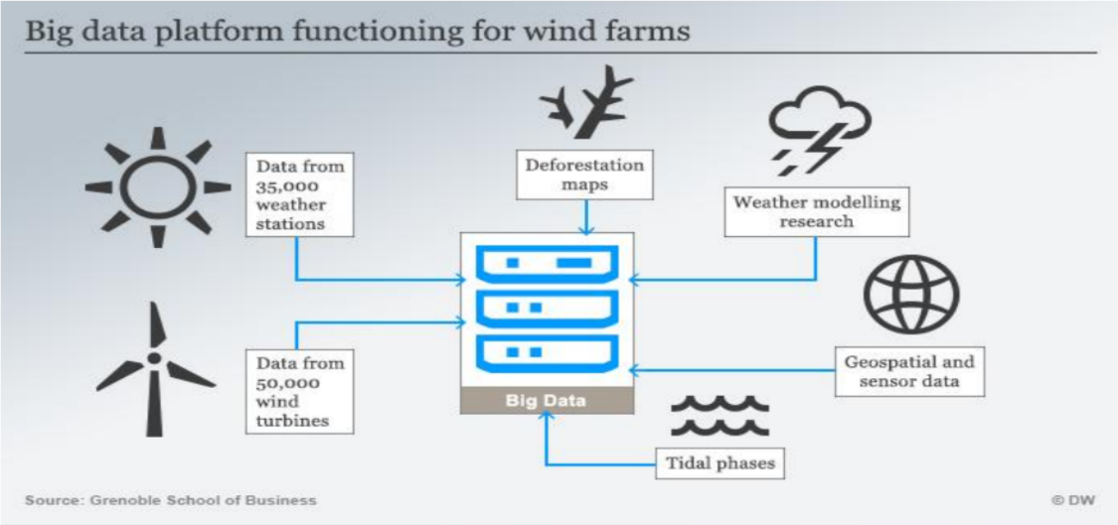

For example, in a wind energy project, we require a certain place where all of the project's demands are met, and these demands may be captured by taking into account a variety of data and criteria that will aid in the project's setup. For instance, weather and wind data.

**Use Cases**

Our proposed project will provide numerous advantages and play a significant role in the sphere of renewable energy. First and foremost, we must upgrade technology. Second, energy consumption prediction can be done with the help of artificial intelligence. Third, forecasting is possible, which will aid in the reduction of production costs. It is possible to create effective backup plants.

**Plan to conduct research**

The Research plan will be carried out in the order listed below.

* Locate data sources that are available: Data science is used in a variety of fields. It is simple to get the research on search engines in a timely manner.
* Identifying the issue is the first step: Many difficulties in renewable energy systems will be easier to identify with big data research: Analysing the entire project plan with current systems to see if and how they can be fixed. We're looking for every conceivable way to carry out our project plans.
* Determine whether additional data sources are required: We'll assess whether our extra sources are worthwhile when we've finalised the framework of the project plan.
* Analytical statistics: Statistical analysis in the context of our project intelligence (PI) will entail gathering and evaluating every data sample in a group of objects from which samples can be drawn.

**Project Plan**

The initial step in our project will be to analyse large amounts of data from various sources. The study plan that has already been discussed will be rigorously implemented.

Following the initial step, we plan to add more machine learning elements to our project to make it a better, more efficient, and faster energy rejuvenation system.

The application of the Python programming language in the field of renewable energy is the main emphasis of this project. This language is useful not only for data analysis, but also for forecasting future scenarios in the energy sector.

The adaptability, extensive libraries, speed limits, and ease of learning are all reasons for utilising this specific language. In this project, we will be studying enormous energy data sets that cannot be easily studied in other technologies, such as python.

Python isn't just for data analytics; it's also useful in fields like artificial intelligence, machine learning, and countless additions.

So now comes the formulation and implementation phase of our project plan. After then, the results will be validated, and it will be maintained in high definition after each test.

**Conclusion**

Renewable energy is flourishing, thanks to technological advancements that are lowering costs and delivering on the promise of a clean energy future. Solar and wind energy is smashing records and is being incorporated into the national electrical system without jeopardising dependability.

As a result, renewables are gradually substituting “dirty” vestige fuels in the electricity industry, resulting in fewer carbon and other types of pollution emissions. However, not all “renewable” energy sources are helpful to the environment.

However, our proposed proposal with the help of data science and data analytics, the Renewable Energy Sector will be able to resolve challenges and give technical benefits.

# References

Ben Richmond, R. N. (n.d.). Renewable Energy Development as a Driver of Economic Growth: Evidence from Multivariate Panel Data Analysis.

Boyle, G. (n.d.). Renewable Energy: Power for a Sustainable Future, 3rd Edition.

Embarak, D. O. (n.d.). *A book on data science.*

Jat, S. (2020). *Data Aggregation and analysis with Python in the field of Renewable Energy Systems.* Nordhausen University of Applied Science.

Kim, M. Y. (2020). Revisiting the Relation between Renewable Electricity and Economic Growth: A Renewable–Growth Hypothesis.

ManassehObib, T. R. (n.d.). *Distributed energy resource aggregation using customer-owned equipment: A review of literature and standards.*